Example: (Two squares) Consider two arbitrary squares ABCD and BFGE with the vertex B in common, see figure below. Prove that straight lines AE and CF are perpendicular for each such two squares.

(Source: Maria Alessandra Mariotti: Reasoning, proof and proving in mathematics education. Proceedings of the 10th International Congress on Mathematical Education (ICME), 4-11 July, 2004. 2008.)

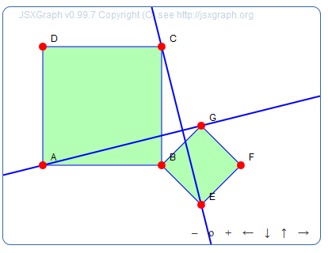

Solution to the example, i.e. proving the given statement, is left to the reader. Here we will only deal with the programming of the illustrative dynamic figure.

Programming:

First of all, we define the Bounding box as follows:

var board = JXG.JSXGraph.initBoard('jxgbox', {boundingbox: [-4, 3, 4, -3]});

To get the figure we start plotting points A, B and E, where B is the common vertex of squares.

var A = board.create('point',[-3,-1]);
var B = board.create('point',[0,-1]);
var E = board.create('point',[1,-2], {name: 'E'});

To construct these squares, we use the `regularpolygon’ element, specifying the first two vertices, i.e. A and B for the first square, and B and E for the second, and the number of vertices, i.e. 4 for both squares. (See https://jsxgraph.org/docs/symbols/RegularPolygon.html)

var square1 = board.create('regularpolygon',[A, B, 4],{name: ‘Square 1’});
var square2 = board.create('regularpolygon',[B, E, 4],{name: ‘Square 2’});

To label the remaining vertices we call them as elements of vertex array, which is indexed from 0, i. e. the vertex A corresponds to square1.vertices(0) etc.

var C = square1.vertices[2];
var G = square2.vertices[3];

Finally, we draw the lines AH and EC.

var p = board.create('line', [A, H]);
var q = board.create('line', [E, C]);

